Alberta Stock Dog Association
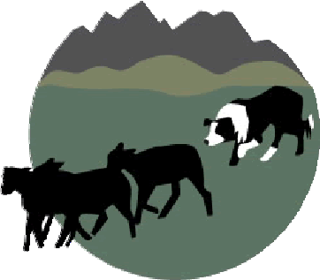
Good Dogs, Good People, Good Times!

Trial Approval Form
Trial Information

Trial Name & Location
Entry Open Date
Entry Close Date
Person in Charge
Person in Charge Address
Telephone & email address
Course Director
Trial Secretary

Trial Description
Please indicate the number of trials you will have for each class:

Novice Pro Novice Nursery
Intermediate Open

Agreement and Signature

By submitting this application, I affirm that the facts set forth in it are true and complete. I understand that if my application is accepted, any false statements, omissions, or other misrepresentations made by me on this application may result in immediate dismissal of all ASDA trial sanctioning rights and privileges.

Name (printed)
Signature
Date

Our Policy

It is the policy of the ASDA (Alberta Stock Dog Association) sanctioning application complete to the ASDA trial director at least thirty (30) days prior to the trial date. The ASDA sanctioning fees must be paid within thirty (30) days of the last trial date. ASDA sanctioning fees are $50.00 per trial (i.e One run $50.00, Two runs ($100.00). Thank you for completing this application form and for your interest in sanctioning with us.

Please send your complete trial sanctioning request form to: ASDA Sanctioning Secretary
email: albertastockdogs@gmail.com

