**AMERICAN HERDING BREED ASSOCIATION 2 DAY TEST AND TRIAL**

**Hosted By: No Chicken Ranch, Okotoks AB**



September 13th & 14th, 2014

HERDING TRIAL ARENA DOG (HTAD I, II, III) TRIAL, SHEEP

Courses #3, and #4

JUNIOR HERDING DOG (JHD) TEST, SHEEP

Judge: Dave Viklund, Molalla OR September 13th AM September 14th PM

Judge: Jerry Kurbatoff, Okotoks AB September 13th AM September14th PM

**Herding Trial Arena Dog (HTAD) I, II, III - Pre Entry $40/Day of entry $50**

**Junior Herding Dog (JHD) - Pre Entry $40/ Day of entry $50**

**Sheep: 3 head**

**Pre Entries close September 5th, 2014 to be included in the catalog**

THERE MUST BE A SEPARATE ENTRY FORM FOR EACH DOG, AND EACH TRIAL LEVEL ENTERED

**Day of entries are accepted September 13th and 14th for each trail up to one hour before the class starts**

**JUDGING SCHEDULED TO BEGIN Each Day following a 9:00AM Handlers Meeting Each Day**

**FIRST HANDLER’S MEETING AT 9 A.M.**

**Handlers meeting will precede all classes**

**Lunch break at judge’s discretion**

**Tentative Judging Schedule for each day:**

**Following 9am Handlers meeting – HTAD III, II, I, Followed by a short break to set up for JHD**

Event Hours: 9:00 am to 6:00 pm, or one hour after the conclusion of this event

Event will be held outside regardless of weather

**Permission has been granted by the American Herding Breeds Association (AHBA)**

**To hold the Trial under the AHBA Rules and Regulations.**

**Mail entries to the Event Secretary:**

Billie Richardson, Suite 104, 14-900 Village Lane, Okotoks AB T1S 1Z6

Phone: (403) 975-0744 or E-mail: [billiegirl@platinum.ca](mailto:billiegirl@platinum.ca)

**OFFICIAL AHBA ENTRY FORM**

AHBA SANCTIONED HERDING TEST AND TRIAL

**NAME OF CLUB or PERSON(S) Sponsoring this Event**: Billie Richardson

Suite 104, 14-900 Village Lane, Okotoks AB, T1S 1Z6

**Date of Event:** September 13th & 14th, 2014

**Pre Entries Close On**: September 5th, 2014

Day of entries accepted till trial fills; Day of entry closes one hour before each class

**Make checks or money orders payable in Canadian funds to**: Billie Richardson

**Send to the Trial Secretary**:

Billie Richardson

Suite 104, 14-900 Village Lane, Okotoks AB, T1S 1Z6

**ELIGIBILITY**

All dogs nine months of age or older are eligible to participate in Herding Trials and JHD. No dog may be entered in two classes on the same course with the same kind of stock under the same judge at any Test/Trial. Bitches in season shall run in drawn running order without adjustment.

Entry form must be returned with the release form signed. Any entries received without the signed release will not be accepted**.**

**NOTE:** A dog must be entered in the name of the person(s) who actually owns it at the time entries are made for the Herding Test or Trial. **A Registration or Tracking Number must be included. Tracking enrollment forms are available on location and will be included with trial results for those folks not yet registered with AHBA, your recorded scores may be delayed until a number is issued by AHBA.**

**ONE FORM PER CLASS PER DOG**

Actual Owner(s):_________________________________________

Address: ________________________

City: ___________________________

Province: _____________________

Zip: ____________

Country:

Telephone: _________________

Email: ________________________

*Agent’s Name (if applicable): ___________________________________*

*Telephone (Agent only): ______________________*

*Email (Agent only): __________________________*

Full Name of Dog: ____________________________________________

Registration OR Tracking Number: _______________________________

Registry: ______________________

Date of Birth: __________

Place of Birth { } USA { } CANADA { } Other

Breed: _____________________

Variety: _________________________

Sex: _____________

Breeder: ___________________________________________________

Sire: ______________________________________________________

Dam: ______________________________________________________

|  |  |  |  |  |
| --- | --- | --- | --- | --- |
| **Please Check the Box for the Trial and Class you want to enter your Dog** | | | | |
|  | **HTAD 1** | **HTAD 2** | **HTAD 3** | **JHD** |
| **Sept 13th AM, DAVE Viklund Course #3** |  |  |  |  |
| **Sept 13th PM Jerry Kurbatoff Course #3** |  |  |  |  |
| **Sept 14th AM Jerry Kurbatoff Course #4** |  |  |  |  |
| **Sept 14th PM Dave Viklund Course #4** |  |  |  |  |

TWO LEGS ARE REQUIRED TO TITLE IN AHBA

AND THERE ARE NO PREREQUISITES –YOU MAY START AT ANY LEVEL

**Prizes**

All Qualifying scores for JHD and HCT will receive a fun herding themed award

High In Trial Herding Arena Dog receives a herding themed award

Reserve High In Trial Herding Arena Dog receives a herding themed award

**CONCESSION**

Bring your own lunch, snacks and beverages will be available on-site.

**Accommodations**

Check out the link to the town of Okotoks, located approximately 6 KM from the trial site <http://www.okotoks.ca/>

Camping Available on Site

**Directions to No Chicken Ranch Trial Site**

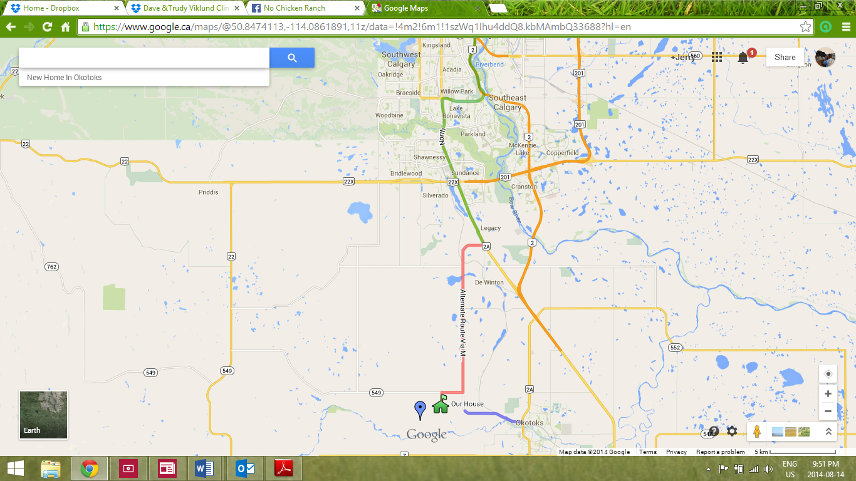

No Chicken Ranch

Jerrold Kurbatoff

# HERDING DOG TRAINING LESSONS AND/OR CLINICS

# PARTICIPANT RELEASE OF LIABILITY

**\*\*\*\*\*\*\*\*\*READ THIS DOCUMENT CAREFULLY\*\*\*\*\*\*\*\*\*\*\*\*\***

In consideration for participating in the **No Chicken Ranch** and the **ASF of Alberta Trudy and Dave Viklund**, the undersigned agrees as follows:

I will keep my dog under my direct control at all times. This means that I will keep my dog restrained on a leash unless we are actively engaged in working livestock under the direction of the trainer.

**I understand that participating in Herding Dog Training Lessons and /or Clinics is inherently dangerous due to the unpredictable nature of both dogs and livestock.**  This activity exposes my dog and I to above normal risks of personal injury, and my property to above normal risks of damage.

**I am participating in this Clinic at my own risk.**

I am solely responsible for my own safety and that of my dog. I release No Chicken Ranch, Jerrold Kurbatoff et al, the owners of the property on which the Clinic and/or Ranch Trial takes place, and their agents, managers, employees and volunteers from any and all liability if I or my dog suffer personal injury and/or my property suffers physical damage.

**I will take no legal action against any of the above persons or establishments upon injury to myself or my dog or damage to my property.**

I am solely responsible for any personal injury and/or property damage incurred by others and caused by me or my dog, including injury or death to livestock. The replacement cost of the livestock used for this clinic and the following Ranch and arena trials will be: Sheep - $ 200.00 ea.

**I will promptly reimburse any party that sustains personal injury and/or property damage caused by me or my dog. In addition, I will indemnify and hold harmless No Chicken Ranch, Jerrold Kurbatoff, and/or the owner(s) of the property on which the Clinic and/or Ranch Trials take place, from any cause of action brought by others against them caused by the actions of me or my dog.**

I declare that I am the legal owner of the dog identified below and that my dog is in good health, including being current on rabies, distemper, parvo and parainfluenza immunizations.

### I HAVE READ THIS AGREEMENT BEFORE SIGNING IT

Signature of Owner/handler: _________________________________________________________

(If under 18 years of age, signature of parent or guardian)

Date or Period covering: May 22, 23 & 24, 2009

Name of Dog’s Owner/Handler__________________________________________________________

Address: ____________________________________________________________________________

Telephone #_____________________________Email:_______________________________________

Dog’s name: ________________________Breed:_________________________Sex:_____Age:______

Emergency Contact: __________________________________Phone #__________________________