Stock Dog Clinic
Peter Gonnet
Aug 12 & 13 2017
Saturday & Sunday 9:00 - 5:00 Approx.

Hands-on dog/handler training clinic using sheep and cattle, in a relaxed and informative environment, the goal is to develop the ability and skill of the dog working on stock.

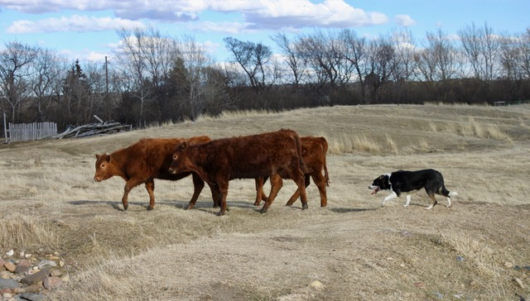

Limit of 12 dogs
Clinic Cost $350.00 per dog Auditors Welcome 75.00 a day
All levels welcome

To Register: contact Chris Jobe
Chris@caninesolutions.ca www.Caninesolutions.ca
Phone: 403 866 6176

Lunch available @clinic for 10.00
Held at Canine Solutions Working Dogs Ranch
15 km south of Dunmore on the Eagle Butte Rd
Take first right onto TWP 102
Take first left onto RR 52
Take first right gate # 10112
Lunch available @clinic for 10.00

Registration Form for Stock Dog Clinic
with Peter Gonnet
Aug 12 & 13 2017
(one per dog/ handler)
Registration deadline Aug 1
Limited to 12 dogs
Auditors Welcome
No refunds unless I we fill your spot.

NAME:________________________________________________________________________________
ADDRES: _____________________________________________________________________________
PHONE: ________________________EMAL: ________________________________________________
DOG’S NAME: _____________________________BREED: ____________________________________

WORKING SPOT $350.00
A DEPOSIT ___$100.00 BALANCE 250.00 DUE AUG 1
___AUDITING $ 75.00
____Lunch available @clinic for 10.00

AMOUNT ENCLOSED $__________________

12:00AM-1:00PM: lunch Approx

Handlers are responsible for the action of their dogs at all times. Keep dogs on leash or kennelled at all times except in the arena.
Liability Waiver:
In consideration of the acceptance of this and the opportunity to train my dog(s), I agree to hold instructor Peter Gonnet, Christine Jobe, Canine Solutions or Mildred Barry and all associates harmless from any claim for loss or injury which may be alleged to have been caused directly or indirectly to any person or thing byte act of this dog or dogs while in or upon the premises or grounds or near any entrance thereto, and I personally assume all responsibility and liability for such claim, and I further agree to hold the aforementioned parties harmless from any claim for damage or injury to the dog or myself, either physically or mentally, whether such loss, disappearance, theft, damage or injury, be caused or alleged to be caused by negligence while in or upon the premises of the Event grounds. The terms of this agreement bind the parties for the current period of training and all subsequent classes/training/events in which they hereafter participate.
Signature: ___________________________________________________________________Date: _______________

Mail: completed registration form with check made out to Canine Solutions
E-transfers: to chris@caninesolutions.ca with completed registration form

Christine Jobe
Attn: Barn Hunt Workshop
10112 Range Road 52
Cypress County AB T1B0K6
chris@caninesolutions.ca
403-866-6176

