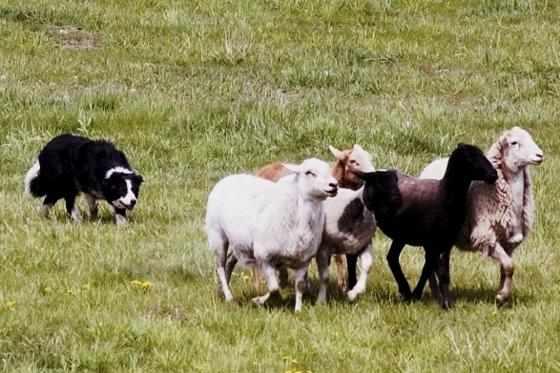
Western Canadian Championship
&
Dawson Creek Trial

Hosted by
Dennis & Jean Gellings
& BC Stockdog Assoc.

Dates: August 7-9, 2015

Judges: Julie Hill & Bobby Henderson, Scotland

Location: Gellings Ranch, 5 min. from Dawson Creek
SouthEast side of Dawson Creek, Look for Encana Events Centre, then ¼ mile East to Rd.215, South to Stop sign. Turn left on Rd.206 and follow until you see trial signs on the left.

Camping: free camping on-site, no services

Qualification
Western Canadians: To qualify, handler and dog team must place once in the top half of an open trial within Western Canada at least one time between January 1, 2014 and July 7, 2015, and you must be a member of a western provincial association by July 7, 2015. Membership must be obtained before qualifying.
Western Canadian Nursery Trial: A Nursery dog is eligible to compete if its third birthday falls on or after July 1, 2015. No other requirements except membership of a western provincial association by July 7, 2015.

Double Lift Championship & Nursery Championship
Double Lift: Ten dogs will compete in the double lift championship and will qualify as follows:
Top 3 scores from each day
Top 4 aggregate from both days

Nursery Championship: Five dogs will compete in the Nursery Championship and qualify as follows:
Top 2 scores from each day
Top 1 aggregate from both days

***Please note: Any dogs entered in ONLY the Dawson Creek trial will not be eligible for prize money.

Entry Fees
Open dogs entered in the WCC are automatically entered in the Dawson Creek Trial. Those dogs not eligible for the WCC may run in the Dawson Creek trial only.
All Nursery dogs are entered in the WCC. There is only one class available for Nursery – the WCC. There are NO USBCHA points available in the Nursery class.
Dawson Creek Trial: Those dogs entered in Dawson Creek trial ONLY are not eligible for prize money or the Double Lift Final, hence the low entry fee. The Dawson Creek trial is two, 1-day trials for USBCHA/BCSDA points only.
Depending on number of entries, 3rd & 4th dogs/class may be accepted. Please include a SEPARATE cheque for these dogs. You will be notified after entries close.

Handler: |  | Address:
Phone: |  | City: | Prov:
Cell: | Email: | Postal Code:
Member of Western Assoc in 2015: Yes No (circle)
Association name

Western Canadian Finals (Includes entry for Dawson Creek Trial):
DOG | AGE | Sex | Trial where dog placed in top half of Open |  | $150/dog
1.
2.
 |  |  |  | Total Open Entries
Additional Dogs | (Please include on separate cheque)
3.
4.
 |  |  | Total Additional Dogs |  | $

Western Canadian Nursery Finals:
DOG | AGE | Sex | $100/dog
1. |  |  | $
2. |  |  | $
 |  | Total Nursery | $
Additional Dogs | (please include on separate cheque)
3. |  |  | $
4. |  |  | $
 |  | Total Additional Nursery Dogs | $

Dawson Creek Trial ONLY
DOG | AGE | Sex | $25 per run | TOTAL
1. |  |  | _______ x 2 | $
2. |  |  | _______ x 2 | $
 |  |  | Total | $
Additional Dogs | (please include separate cheque)
3.

4.

 |  |  | Total additional dogs | $

Entries Open June 1, 2015 and deadline is July 6, 2015. No refunds after July 6th, 2015 without vet/doctor letter. Entries accepted on first come, first served basis. Cross entries allowed between classes unless numbers warrant otherwise. Trial organizer reserves right to limit entries.
Stock Dog Release Form: I hereby release from liability the Western Canadian Finals Trial Committee, the the BC Stock Dog Association, Dennis &/or Jean Gellings and the exhibitors from any costs incurred as a result of damage to me, my property and or my dog(s). My payment and signature acknowledge that I have read this form and that I will accept liability for any cost incurred as a result of damages caused by me or my dog(s) to the facilities, sheep, other livestock, dog(s) or persons. Replacement cost of stock is $200.00 per sheep and/or vet bills.

Signature of owner/handler:__________________________________________________Date:___________________

PAYMENT MUST ACCOMPANY ENTRY FORM
Cheque payable to Jean Gellings Box Box 931, Stn. Main, Dawson Creek, B.C. V1G 4H9.

For further information:
Dennis & Jean Gellings - 250-786-0303, dgelling@telus.net
Jennifer L’Arrivee – 250-569-0359, sheepdog@telus.net

